Fictional Company/Organization
Diasure is a company created by Margvinatta S. and Niyati P. The mission and vision of the company is to prevent diabetes misdiagnosis through data accuracy and empower individuals with accessible, and reliable tools to correctly identify their type of diabetes, prevent misdiagnosis, and receive the right care.
Data
- At Diasure, data is collected through hospital records, insurance companies, laboratories, and clinics and collectively added to a cloud-based warehouse. Everything from patient demographics, family history, lab results, blood sugar levels, BMI, insulin, ketones, diet, lifestyle, diabetes symptoms(urination frequency, thirst, exhaustion, and weight loss), Diastolic and Systolic blood pressure is collected through the sources.
- Data quality checks happen before and after extraction to ensure the data is cleaned and organized appropriately. Mainly the ETL integration approach is followed. For duplicates, if patient data is the same for all columns the duplicate is deleted as well as if there is missing data. Accuracy checks happen to remove repeated/duplicate data and missing values. Ensure format consistency across columns, change columns names to comply with SQL workbench.
- This is an overview of the database including a few sources, staging, storage, and presentations.

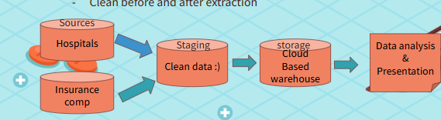
- What are the data usage agreements with your company?
- Since a lot of personal data is collected so HIPPA is strictly enforced, and only authorized users have access. The warehouse is also encrypted.
Database Design
- This is the schema including all the tables that are used at Diasure.
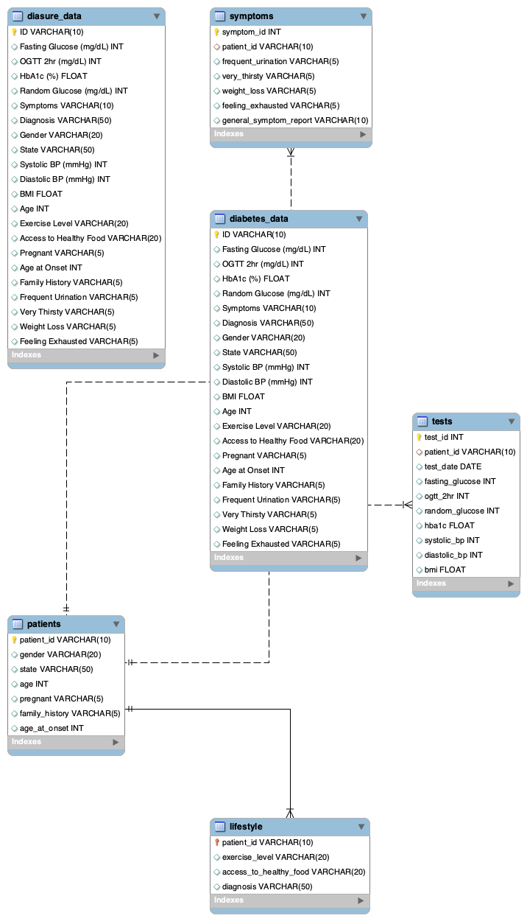
There are a total of 5 main tables titled symptoms, diabetes data, patients, lifestyle, and tests. The patients table, symptoms, and tests tables are connected to the diabetes table through patient id, symptom id, and test id respectively. The lifestyle table is connected to the patients table through patients id.
Database Storage
All data is stored on a cloud-based warehouse because data needs to be access by multiple people at the same time for research and progress. To manage the data SQL workbench, RStudio, and Shiny app is used. For recovery, data is refreshed and uploaded daily and can be easily recalled based on the day if needed.
Database Access and Analysis
- The following query was written to find how many patients are diagnosed with diabetes by state.
- 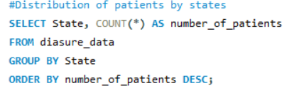
- For all visualization, RStudio and Shiny app is used to create user-friendly surfaces for all to learn about various demographic and disease information. Refer to the picture below for a visual based on the query.
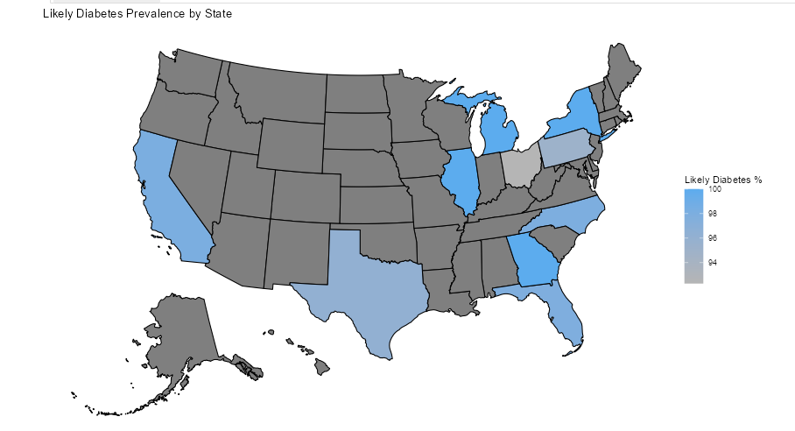
Conclusion
Diasure is a fully funded company because diabetes affects millions of people not just in the US but worldwide. A misdiagnosis hinders proper treatment and can be detrimental to health and quality of life for the individual. Being the 8th leading cause of death in the US, there is not information about misdiagnosis and prevention of a misdiagnosis. At Diasure we aim to bridge the gap in missing data and help individuals improve their well being by ensuring a proper and accurate diagnosis.

